YUVA INTERNSHIP
Junior Data Analyst – Agribusiness
Task 2 : Crop Yield Optimization

INTRODUCTION

Crop yield optimization is a critical component of sustainable agriculture and food security, especially in regions like India where climatic variability and soil diversity pose significant challenges to consistent agricultural output. This report presents a comprehensive, data-driven strategy aimed at enhancing crop productivity by analyzing key environmental and agronomic factors. Leveraging publicly available datasets from the Food and Agriculture Organization (FAO), the Indian Meteorological Department (IMD), and the Indian Council of Agricultural Research (ICAR), the report explores how variables such as precipitation, temperature, soil type, fertilizer application, and crop rotation patterns influence yield outcomes.
The analysis focuses on rice and wheat—two staple crops in India—and evaluates their compatibility with regional conditions using a case study from East Godavari district in Andhra Pradesh. By comparing crop requirements with actual climatic and soil data, the report identifies areas of alignment and potential improvement. It also provides practical recommendations including optimized irrigation techniques, soil enhancement practices, targeted fertilizer strategies, and crop rotation plans that can be implemented at the farm level.
The report is designed to be both informative and actionable, offering insights that can guide farmers, agribusiness planners, and policymakers in making data-informed decisions. Its emphasis on sustainability ensures that the proposed strategies not only improve yield but also preserve long-term soil health and resource efficiency.

Key Factors Influencing Crop Yield

Precipitation
Rainfall is one of the most critical environmental factors affecting crop yield. It directly influences water availability for plant growth, nutrient absorption, and overall physiological development. Both excessive and insufficient rainfall can negatively impact crop performance. For instance:
- Rice requires approximately 1200 to 1500 mm of rainfall annually. It is highly sensitive to water stress, and inadequate rainfall can lead to poor tillering and reduced grain formation.
- Wheat, on the other hand, performs optimally with 500 to 1000 mm of rainfall. Excess water during its growth stages can cause lodging and fungal diseases.
In regions with erratic rainfall patterns, waterlogging may damage root systems, while drought conditions can stunt growth and reduce yield. Effective irrigation planning and water conservation practices are essential to mitigate these risks.

Temperature
Temperature plays a vital role in determining the rate of germination, vegetative growth, flowering, and grain development. Each crop has a specific temperature range within which it performs best:
- Rice thrives in warm climates, with an optimal temperature range of 25°C to 35°C. Temperatures above 35°C during flowering can lead to spikelet sterility and reduced grain set.
- Wheat prefers cooler conditions, ideally between 15°C and 25°C. Exposure to high temperatures during grain filling can accelerate maturation and reduce grain weight, while cold stress during early growth can delay development.
Understanding local temperature trends and selecting crop varieties suited to those conditions is essential for maximizing yield.

Soil Type
Soil characteristics such as texture, structure, fertility, and drainage capacity significantly influence crop performance. The type of soil determines how well it retains water and nutrients, and how easily roots can penetrate:
- Loamy soil is considered ideal for most crops due to its balanced composition of sand, silt, and clay. It offers good drainage, aeration, and nutrient-holding capacity.
- Clayey soil retains water effectively but can become compacted and poorly drained, increasing the risk of root rot and limiting oxygen availability.
- Sandy soil drains quickly and is often low in nutrients. It may require frequent irrigation and soil amendments to support healthy crop growth.
Soil testing and appropriate amendments such as compost or organic matter can improve soil structure and fertility, enhancing yield potential.

Fertilizer Use
Nutrient management is a cornerstone of crop yield optimization. The balanced application of essential macronutrients—nitrogen (N), phosphorus (P), and potassium (K)—is crucial for healthy plant development:
- Nitrogen promotes vigorous leaf and stem growth, which is especially important during the vegetative stage.
- Phosphorus supports root development and is critical during early growth and reproductive stages.
- Potassium enhances flowering, grain development, and resistance to diseases and environmental stress.
Overuse or underuse of fertilizers can lead to nutrient imbalances, soil degradation, and reduced crop performance. Precision fertilization based on soil nutrient status and crop requirements is recommended.

Crop Rotation
Crop rotation is a sustainable agricultural practice that involves growing different types of crops in succession on the same land. This method helps maintain soil fertility, reduce pest and disease pressure, and improve overall farm productivity:
- Leguminous crops, such as chickpeas or lentils, fix atmospheric nitrogen into the soil, enriching it for subsequent cereal crops like rice or wheat.
- Rotating crops also disrupts pest and disease cycles, reducing the need for chemical pesticides and fertilizers.
Implementing a well-planned crop rotation schedule can lead to long-term improvements in soil health and yield stability, making it a valuable strategy for sustainable farming

DATA SOURCES
To conduct a comprehensive analysis of crop yield optimization, this report utilizes publicly available datasets from reputable national and international organizations. These datasets provide essential information on climate conditions, soil characteristics, and agro-ecological classifications relevant to agricultural planning.

3.1 FAO Agro-Ecological Zones (AEZ) Dataset
The FAO AEZ dataset offers global classifications of agro-ecological zones based on climate, soil type, terrain, and land use suitability. It is widely used for agricultural zoning, crop suitability assessments, and land resource planning. This dataset helps identify regions where specific crops are most likely to thrive under prevailing environmental conditions.
- Source: Food and Agriculture Organization (FAO)
- Access Link: FAO AEZ Dataset

3.2 Indian Meteorological Department (IMD) Climate Records
The IMD provides detailed district-level data on rainfall and temperature across India. This information is critical for understanding seasonal variations, identifying drought-prone or flood-prone areas, and aligning crop calendars with climatic patterns. The dataset includes historical and real-time data useful for both short-term and long-term agricultural planning.
- Source: India Meteorological Department (IMD)
- Access Link: IMD Rainfall Portal

3.3 ICAR Soil Classification Maps
The Indian Council of Agricultural Research (ICAR) offers soil classification maps that detail the texture, fertility, and degradation status of soils across different regions of India. These maps are essential for determining soil suitability for various crops, planning fertilizer application, and implementing soil conservation strategies.
- Source: Indian Council of Agricultural Research (ICAR)
- Access Link: ICAR Soil Maps

CASE STUDY : RICE CULTIVATION IN AP

To illustrate the crop yield optimization strategy, this section presents a case study of rice cultivation in East Godavari district, located in Andhra Pradesh. Using publicly available data on rainfall, temperature, soil type, fertilizer usage, and crop rotation practices, we assess the district’s suitability for rice production.

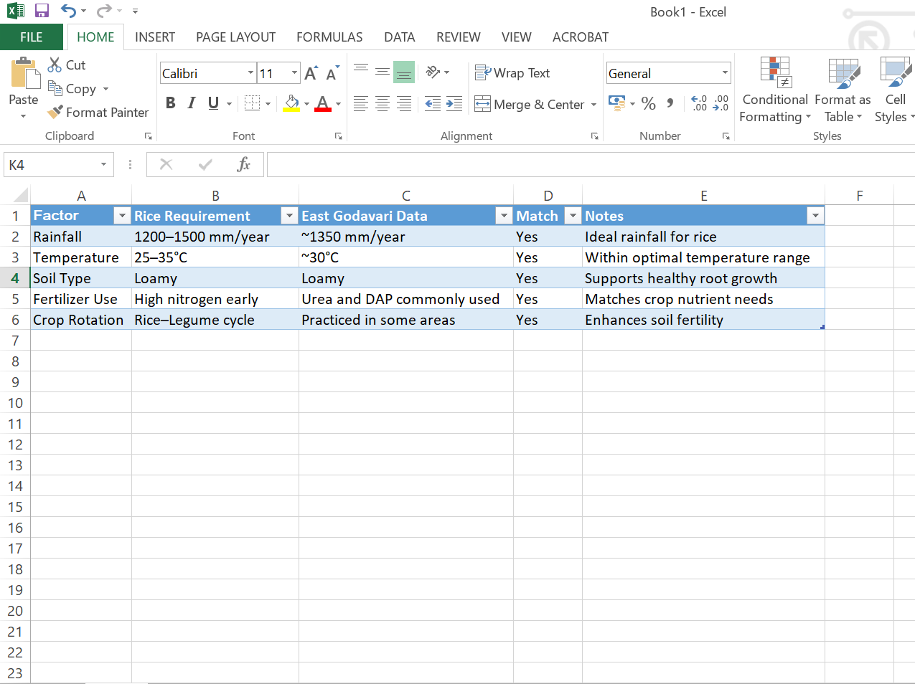

Based on the data, East Godavari district meets all major agronomic and environmental criteria for successful rice cultivation. The region receives adequate rainfall and maintains temperatures within the optimal range for rice growth. Loamy soil, which is prevalent in the district, provides excellent drainage and nutrient-holding capacity, supporting robust root development.
Fertilizer practices in the area typically include the use of urea and diammonium phosphate (DAP), which align well with the nutrient requirements of rice, particularly during its early growth stages. Additionally, crop rotation involving legumes is practiced in parts of the district, contributing to improved soil health and reduced dependency on synthetic fertilizers.
Overall, East Godavari demonstrates high suitability for rice cultivation, and with targeted interventions such as precision irrigation and enhanced crop rotation planning, yield outcomes can be further optimized.
RECOMMENDATIONS FOR
YIELD OPTIMIZATION

Based on the analysis of environmental and agronomic factors, as well as the case study of rice cultivation in East Godavari, the following strategies are recommended to optimize crop yield. These recommendations are practical, regionally adaptable, and grounded in sustainable agricultural practices.

5.1 Irrigation Management
Efficient water management is essential for maintaining crop health, especially in regions with variable rainfall. In areas with low or inconsistent precipitation, farmers should consider implementing drip or sprinkler irrigation systems. These methods deliver water directly to the root zone, minimizing evaporation and runoff.
Additionally, rainwater harvesting systems can be installed to collect and store water during the monsoon season. This stored water can be used during dry spells, reducing dependency on groundwater and ensuring consistent irrigation throughout the crop cycle.

5.2 Soil Enhancement
Improving soil structure and fertility is key to supporting healthy plant growth. The application of organic compost or green manure enriches the soil with nutrients and enhances its ability to retain moisture. These organic amendments also promote microbial activity, which is beneficial for nutrient cycling.
Mulching—using crop residues or organic materials to cover the soil surface—can help retain moisture, suppress weeds, and reduce erosion. This practice is particularly useful in sandy or degraded soils.

5.3 Fertilizer Strategy
A targeted fertilizer strategy can significantly improve crop performance. Nitrogen-rich fertilizers, such as urea, should be applied during the early vegetative stages to promote leaf and stem development. During the flowering and grain formation stages, potassium-based fertilizers can enhance yield quality and resistance to stress.
To avoid overuse or underuse of nutrients, farmers are encouraged to conduct soil testing prior to planting. This allows for customized fertilizer application based on the specific nutrient profile of the soil.

5.4 Crop Rotation Planning
Crop rotation is a proven method for maintaining soil health and reducing pest and disease pressure. Rotating rice with leguminous crops such as chickpeas or lentils helps replenish nitrogen in the soil, reducing the need for synthetic fertilizers.
Alternating rice with oilseed crops like mustard or sunflower can diversify farm income and disrupt pest cycles. A well-planned rotation schedule also improves soil structure and reduces the risk of nutrient depletion.

5.5 Climate Adaptation
Given the increasing unpredictability of weather patterns, climate adaptation strategies are essential. Farmers should select rice varieties that are drought-tolerant or flood-resistant, depending on local conditions. These varieties are bred to withstand environmental stress and maintain yield stability.
Adjusting sowing dates to align with monsoon onset can also improve crop establishment and reduce exposure to adverse weather during critical growth stages. Access to localized weather forecasts and advisory services can support timely decision-making.

CONCLUSION
This report demonstrates how publicly available data can be used to optimize crop yield through strategic planning. By aligning crop requirements with regional climate and soil conditions, farmers can enhance productivity while maintaining sustainability. The case study of East Godavari shows that rice cultivation is highly suitable in the region, and further improvements can be made through targeted interventions in irrigation, soil management, and crop rotation. These recommendations are scalable and adaptable across different agro-climatic zones in India

THANK YOU

